T1

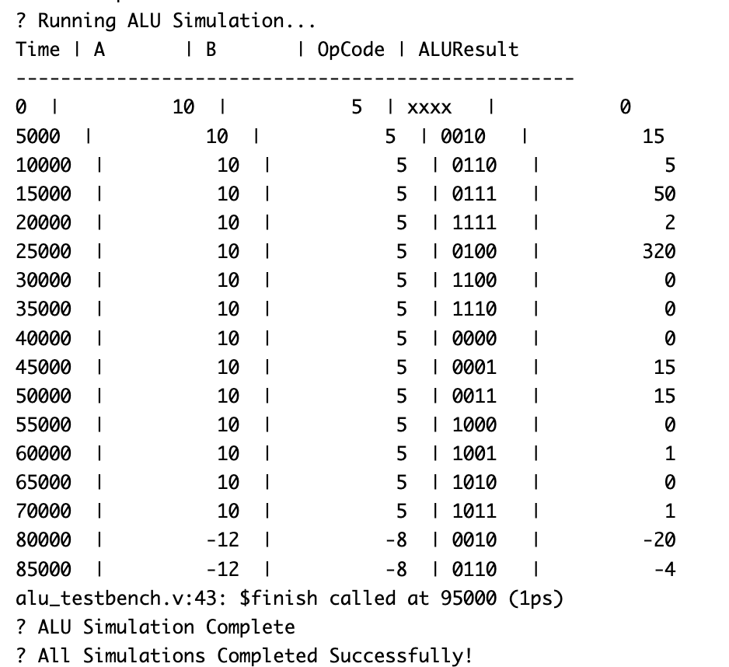

T2

T3

T4

T5

T6: The #delay specified in step 13 was 5 “time units”. What is the real value of these 5

“time units” in the simulation?

* The real value of these 5 times units is 5 nano seconds.

T7: What is the purpose of a testbench? Why is it needed for each module (ALU and CU)?

* The purpose of a testbench is used to test and verify the functionality of a module. In this case, a testbench for ALU was needed to verify the correct implementation of operations given an input, A and B. these operations included addition, subtraction, shifting and comparison. The CU testbench was needed to verify that the correct opcode generated for each control signal.

T8: Can we obtain power, performance, area (PPA) results with the testbench? Why?

* No, a testbench cannot obtain Power, Performance, and Area (PPA) results because it is only used for functional verification in simulation. Testbenches do not model real hardware behavior, they simply check if a module produces the expected outputs.